**Submitted By:**

**Alharbi Theyab**

**Hastimal Jangid**

**Neha Choudhary**

**Wuchen Wang**

**Project Plan**

**I. Introduction:**

Our plan is to create an automatic researcher’s journal to add in the area of research. Research work is mostly available in paper-based form and storing and managing papers is a big hassle. Hence, creating a web-based application that enables storing the electronic copy of lab note instead of huge files in the shelves will be a smarter idea.

**II. Project Goal and Objectives (Revised):**

**Overall Goal:** Main goal of this project is to save the time of researchers, making the documents easily available and confidential. This web app will be private to the researchers and therefore, it will provide more security and privacy to the sensitive data. It will also allow people to interact with those having the same area of research and discuss on a particular topic and sharing their work with each other.

**Specific Objectives:**

* Our project will help to store the research data in electronic-form.
* It will allow to maintain the privacy and confidentiality of the data by restricting access to the page.
* It will also be helpful in data sharing; especially, among the group working having same area of interest.
* Finally, it will also help in saving papers and hence, saving environment.

**Significance:** This project is all about making an experiment tracker, intended for researchers. It would be a web application and the basic idea is to create electronic version of the lab notes and store sensitive research data in the database. Researcher can feed essential experimental data into the website and the server will sort the data based on the time they were being uploaded. The web page will be private to a group with restricted access. This project will play a vital role in the area of research by offering easy record keeping and also maintaining the confidentiality of data; researcher can also go for data sharing with others, having same area of interest.

**III. Project Background and Related Work:**

Some systems like lab notes archiving system (Lab archives, cited in reference) already exists and are commercially available. Such system helps to organize electronic laboratory data and serves as backup resources on the remote server. The system provides sharing and archiving functions and the contents of the archived file will not be logged in a journal-like fashion.

A framework called Bioinformatics Computational Journal (BCJ) was developed to manage experiments in bioinformatics research (Feagan, Rohrer et al. 2007). The framework was intended for facilitating collaboration among researchers and undertaking various complex experiments. The environment has a design of uniform data interface which provides a high-level, data entry type to the user. Other work was done in a way that emphasizes the acceptance probability of electronic copy of data to be adopted in academia, as well the issue of intellectual property of documented research data (Kloeckner, Farkas et al. 2014).

Another application that shares some common features with our project is an iPhone application called Heyday (Heyday, cited in reference). The application automatically keeps a journal of photographs taken by the device that are accessed by the application and arranges them chronologically. Heyday is working further to produce a coherent layout of the photos that will restrict the access to journal content.

**IV.** **Proposed System**

**1) Requirement Specification**

* **Functional, Non-functional, Technical/Business Requirements:**

- Functional requirements:

1. A group can include as many users it wants, but only one administrator to the group is permitted.

2. A result display can be a display for the whole group, or can be the display for one single user.

3. The result display includes entries of documents.

4. A document has its own type, which can be textual strings, figures, videos.

5. A user can join a group by signing up for an account in the system, and also request authentication for a specific group during the same session.

6. A user must be in at least one group.

7. User inputs experimental data in a chronological order,

8. The server automatically schedule the presentation of the data stored, which is input by user earlier, by rearranging the layout of document representation according to the time of submission, or the priority set by the group administrator.

9. The document with highest priority or is submitted with most recent time-stamp will be displayed on top of each group main page.

10. The main page will be displayed on a daily basis. The automatic layout can be retrieved and displayed according to detailed index of date, but one page will only display the documents for a day.

11. Only authorized users have access to the group page, the contents of groups will be separated from each other.

12. The individual document displayed on a result display page contains hyperlink to a detailed representation of the contents of that document.

- Non-functional requirements:

1. System performance: it will be dependent on the number of requests at a single time and the scalability of web-server. Deployment shall be done on an environment that supports load-balancing and instantiation of multi-threaded server-side servlets.

2. The system shall be a cross-platform application.

* **Business Process/Workflow Analysis:**

The user activity is shown in Figure 1.

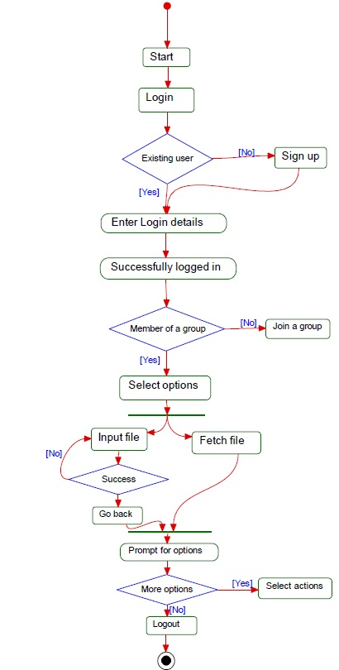

Figure 1. UML Activity diagram for user.

* **Technological and Architectural Requirements:**

1. Frontend engine.

HTML5, JQuery, CSS, Bootstrap

2. Backend engine.

JavaEE, servlet, JavaServer Pages and Apache Tomcat 7.0

3. Database server.

MongoDB

**2) Framework Specification:**

* **Assumption and Principles:**

Our project is meant to provide high level security to the data used in research. Experimental data is highly confidential and needed to be secured while it is being shared with others. This proposed system will achieve the goal by generating and circulating a group code to one who belongs to the group. Anyone who does not belong to the research group will not get the code and hence, cannot access the information available. This will provide privacy to the journal in effortless manner.

* **Methodologies and Algorithm:** Not Applicable to this project.
* **Architecture Pattern:**

This web application will adopt a model-view-controller (MVC) architecture pattern that encompasses the following components:

1. Frontend engine.

The feature of a concise layout of the journal will be mainly implemented in this component.

2. Backend engine.

The backend engine will serve as the controller in the architecture pattern. The features of automatic scheduling of input results and setting priority for display will be mainly implemented in this component and all the application specific logic belong to this component.

3. Database server.

The user’s input data will be the main model in the architecture, which conforms to the MVC pattern. There will be data accessing objects in the server-side that calls the database connectivity API to insert/update/delete entries in the database.

* **Overall system model:**

As shown in Figure 2, the classes belong to the components in the application server were modeled in UML class diagrams.

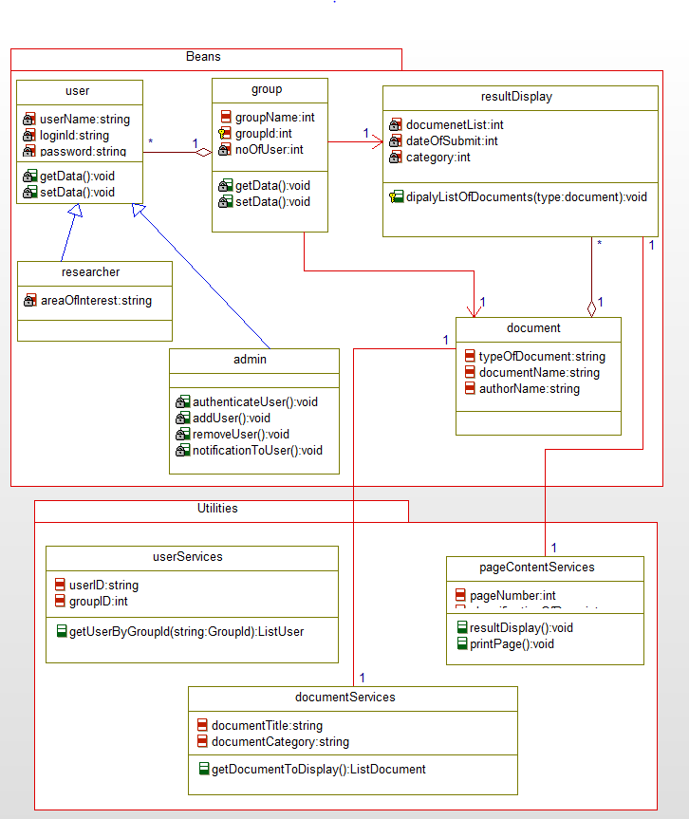

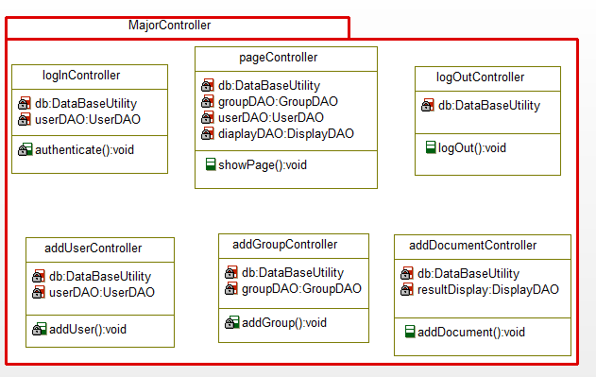

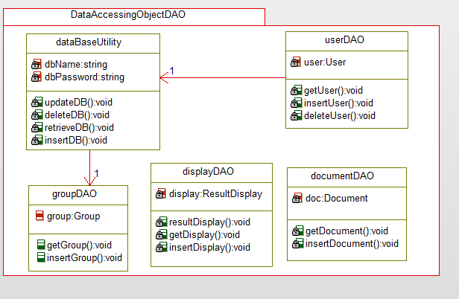

Figure 2. A UML design of the back-end classes for the system.

* **System Architecture Diagram:**

As shown in Figure 3, the system architecture composes the web client, application server and database server.

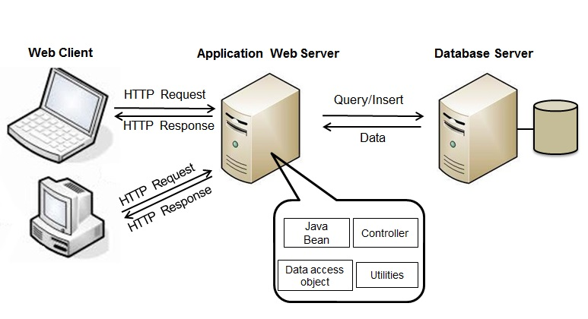

Figure 3. Architecture of the web application.

**3) System Specification:**

* **Existing Services:** Not Applicable.
* **New Services to be Built:**

We are going to provide three services in this project and they are: Data Storage, Data Retrieval and Privacy Preservation.

1. **Data Storage:** Data will be stored securely at the end of the day by every participating user. Server will manage those data and sort them based on the time they were uploaded, access to this data is restricted.

**Class Diagram:**

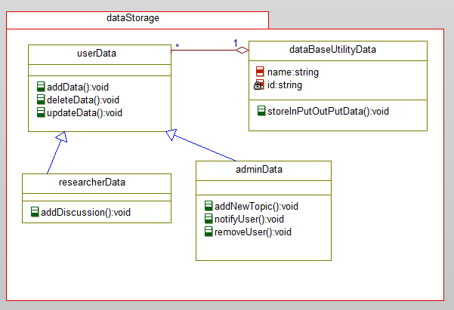

Figure 4. Class diagram for data storage service

**Sequence Diagram:**

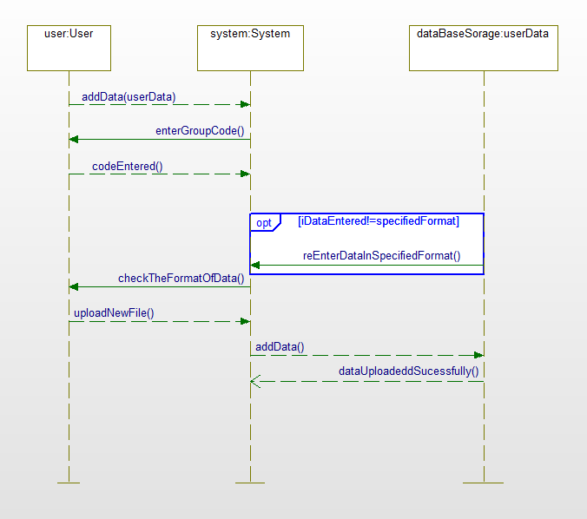

Figure 5. Sequence diagram for data storage service

1. **Data Retrieval:** To fetch the data from the database one needs the permission of administrator and also required to be the member of group. All these research data are read-only data hence, no one else than the data owner can make any changes to it.

**Class Diagram:**

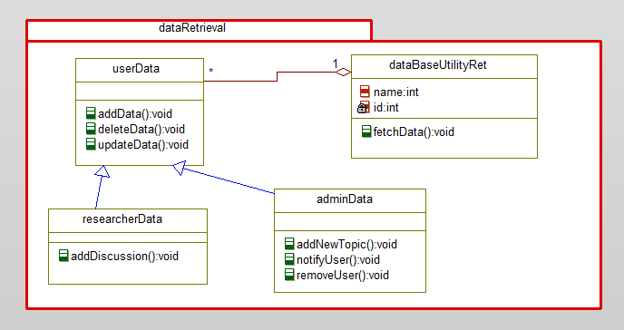

Figure 6. Class diagram for data retrieval service

**Sequence Diagram:**

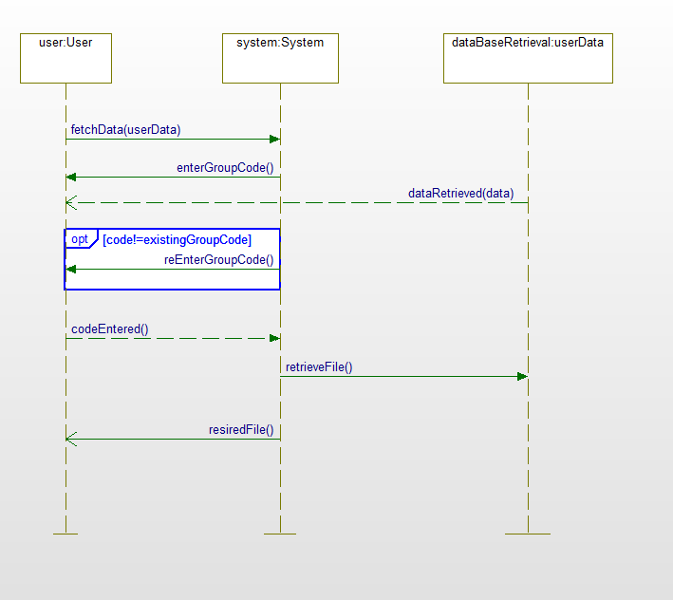

Figure 7. Sequence diagram for data retrieval service

1. **Privacy Preservation:** This is one of the most important services offered by our project. Privacy preservation is the main concern of data owner. They want to maintain the confidentiality of their sensitive data, their plan and approach to reach the goal until it is being published. Therefore, it is required to meet the expectation of data owner and provide them with the desired service. Here, in order to avoid security issue we are going to maintain a group code for every research group; group code will be private to the members of group and will be authenticated by the group administrator.

**Class Diagram:**

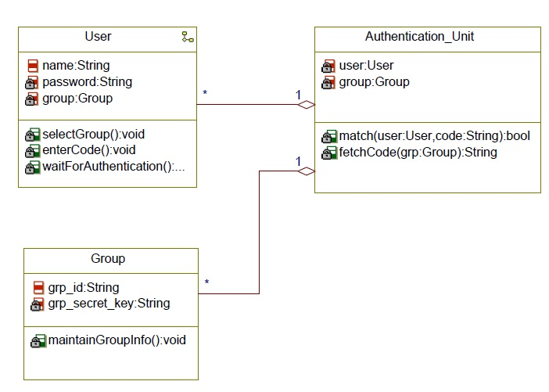

Figure 8. Class diagram for privacy service

**Sequence Diagram:**

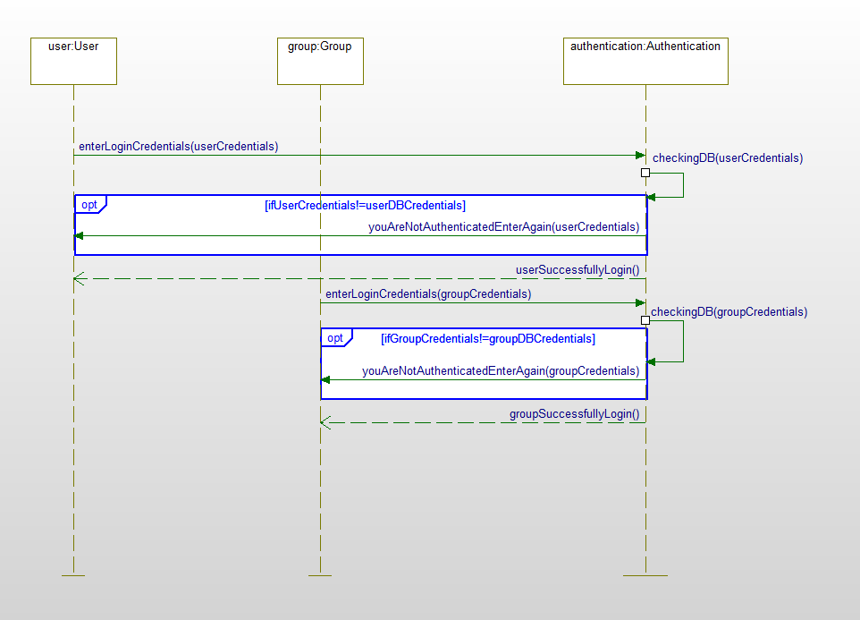

Figure 9. Sequence diagram for privacy service

* **Service Specification:**
* **Operational Description:** As project is a researcher’s journal so in this researcher is going to add data related to his daily work in the area of research and further researcher and member of his group can retrieve all work. This web-application enables all members to access data from their own group.
* **Input/output for Services:** Researcher can add/fetch data added by him/herself and even can access all journals of the group according to area of interest.
* **Constraints/Exceptions:** All group members are authenticated with a id and if this id is not a valid then researcher wouldn’t be authenticated by admin and system will throw an error/exception.
* **Service flow/alternative flow:** This journal will provide the basic services required to handle a research team with *data storage, data retrieval and privacy preservation.*
* **Priorities:** The privacy is one of the main services and can be treated as priority such that only all members of a particular group are able to access while other members are not able to access journals.
* **Design of Mobile Client:** Not Applicable.

**V. Plan by Services**

Project ScrumDo link:

https://www.scrumdo.com/projects/project/researchers-journal/summary

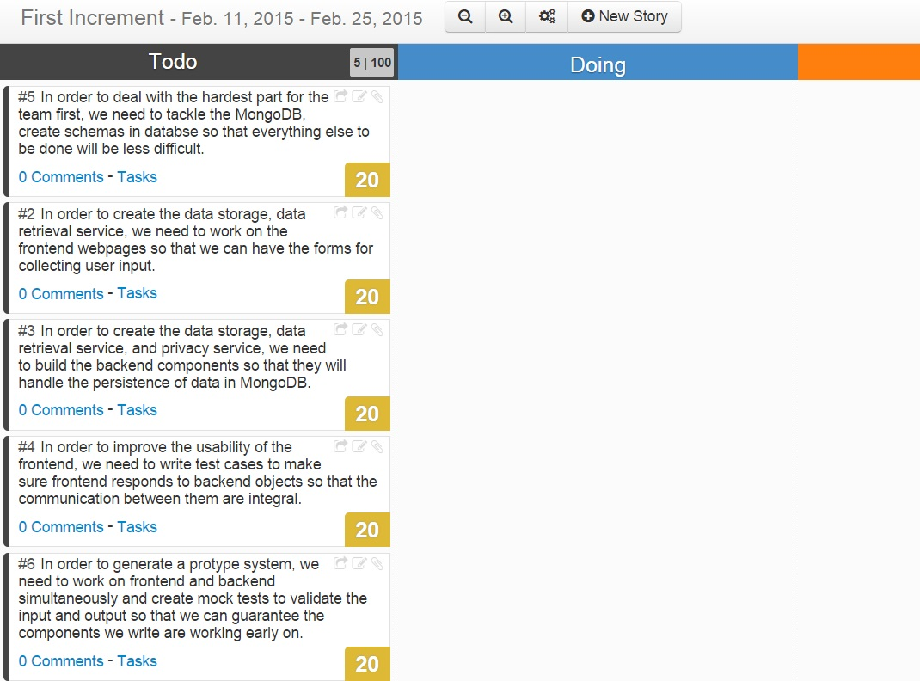

Figure 10. The ScrumDo dashboard for first increment.

**VI. Risk management**

**Technological and Architectural Requirements:** We planned to useRelational database MySQL as the database server. The main plan was to maintain user’s input data inside the main model in the architecture, which conforms to the MVC pattern. However, now we are planning to move to NoSQL database; our plan is to go with MongoDB, which is different when compared to table-based relational database structure. Proceeding with no hand on experience on NoSQL database is a great challenge for the entire team and we are working on this challenge to achieve success. There will be data accessing objects in the server-side that calls the database connectivity API to insert/update/delete entries in the database. None of the features are directly implemented in this component, nevertheless, most of them are dependent on the database persistence functionality

**VII. Bibliography**

http://www.labarchives.com/

http://www.hey.co/

Feagan, L., J. Rohrer, A. Garrett, H. Amthauer, E. Komp, D. Johnson, A. Hock, T. Clark, G. Lushington, G. Minden and V. Frost (2007). "Bioinformatics process management: information flow via a computational journal." Source Code Biol Med **2**: 9.

Kloeckner, F., R. Farkas, T. Franken and T. Schmitz-Rode (2014). "Development of a prediction model on the acceptance of electronic laboratory notebooks in academic environments." Biomed Tech (Berl) **59**(2): 95-102.